Developer Guide to Create Ginger Help items

ToolTip for field + if help exist F1 or I icon click

Help Key – per field or window/page

Can show unique help – actionEdit Page – for the action

Ginger Help –chm – windows standard help file will require work… not simple..

Unit test – make sure all help keys connected to docs

Today support site – not maintained

No access to externals

Tool Tip

Solution needed:

Simple folder for docs

Version control

Interactive help – link to obj ids

Store movies

Sepearet part in setup – min + max

Use winword template – force formatting

Link on elements – click F1 for help

Folder – Index is the default display

Solutio

Java Action

Selenium Grid

SeeTest

Treeview – sort order

Search keywords

Resources file ID🡪 Filename or folder

IHelpItem

F1 show help – per item in focus…

For each file – copy to output directory

In Window or Page add

<Page x:Class="Ginger.Actions.ActionEditPage" xmlns:Ginger="clr-namespace:Ginger" xmlns:Actions="clr-namespace:Ginger.Actions"

xmlns="http://schemas.microsoft.com/winfx/2006/xaml/presentation"

xmlns:x="http://schemas.microsoft.com/winfx/2006/xaml"

xmlns:mc="http://schemas.openxmlformats.org/markup-compatibility/2006"

xmlns:d="http://schemas.microsoft.com/expression/blend/2008"

xmlns:h="clr-namespace:Ginger.Help"

mc:Ignorable="d"

Title="Edit Action"

Width="1000"

Height="800"

d:DesignHeight="800" d:DesignWidth="1000" SizeChanged="Page_SizeChanged"

h:GingerHelpProvider.HelpString="Action Edit Page"

>

Specific Element help

<ComboBox Grid.Column="1" x:Name="cboLocateBy" SelectionChanged="cboLocateBy_SelectionChanged" Style="{StaticResource @InputComboBoxStyle}" h:GingerHelpProvider.HelpString="Action Locate By" />

Creating new mht file

Using word

Select from template folder

For example ActionTemplate.dotx

It will create a new doc based on this template

How to update style for all docs:

Open the dotx file: open winword and select the file, do not double click reset

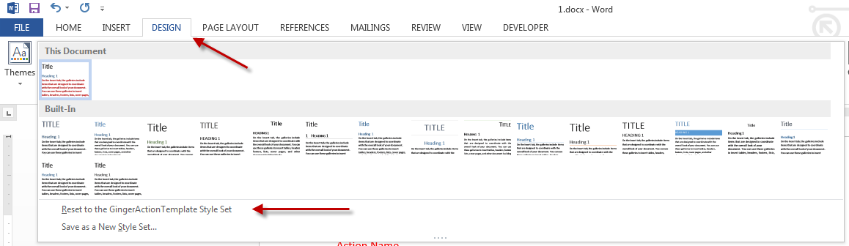

Modify/Rename a style

